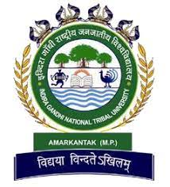
Indira Gandhi National Tribal University, Amarkantak (M.P.)
Undergraduate Programmes
Environmental Science
IVth Semester Examinations, September - 2023
Subject –Disciplinary Minor - Urban Ecosystems Paper Code- EVS-DMI T 444

Max Time: 2 Hrs.

Max Marks: 30

Note: Section A is compulsory. Attempt any four questions from Section B
SECTION A
1. | Write short notes on:  - What is urban sprawl, and what are its common characteristics and impacts on urban development?  - What are man-made ecosystems, and how do humans intentionally create or modify these environments? | (3x2=6)
SECTION B
2. | What are green belts, and what roles do they play in urban planning and environmental conservation? | (6)
3. | Explore the intricate connection between urban environments and ecosystem services, highlighting the dynamic interaction between humans and these essential resources. | (6)
4. | What does the term "urbanization" entail? How do urban areas distinguish themselves from non-urban regions, and what are the distinct challenges and concerns linked with the process of urbanization? | (6)
5. | Describe in detail the concept of green buildings, outlining their fundamental principles, environmental benefits, and significance in promoting sustainable urban development. | (6)
6. | What is the concept of ecosystem services within an urban ecosystem, and how do these services contribute to the well-being and sustainability of urban environments? | (6)
7. | How does the concept of ecological footprint apply to urban ecosystems, and what are the specific factors within an urban environment that contribute to or influence the ecological footprint? | (6)
8. | What are smart cities, and how do they utilize technology and data to enhance urban living and resource management? | (6)

******

